**Basic technology** jss1 e-note 3rd term.

Scheme of work

Week 1 revision of last term work

Week 2 wood work hand tools

Week 3 wood work hand tools(cont)

Week 4 metal work hand tools

Week5 metal work hand tools(cont)

Week 6 maintai ace of tools and machine

Week 7 basic electricity

Week 8 basic electricity (cont)

Week9 basic electricity (cont)

Week 10 basic electricity (cont)

Week 11 revision

Week 12 examination

Week 1; revision

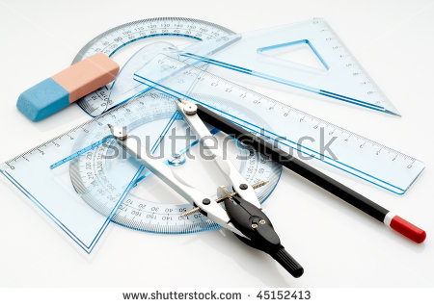

List 5 drawing instruments and state their uses

2.draw tee square and label the parts

Week 2; wood work hand tools

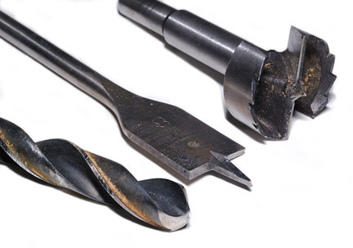

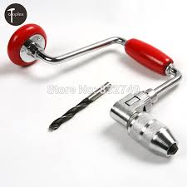

What is the definition of boring tools?

In machining, **boring** is the process of enlarging a hole that has already been drilled (or cast) by means of a single-point cutting **tool** (or of a **boring** head containing several such **tools**), such as in **boring** a gun barrel or an engine cylinder.

Cutting tools; [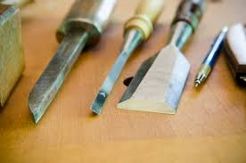](https://www.google.com/imgres?imgurl=https://woodandshop.com/wp-content/uploads/2014/06/how-to-make-mortise-and-tenon-joint-woodworking_DSC7336.jpg&imgrefurl=https://woodandshop.com/how-to-make-mortise-and-tenon-joints-with-hand-tools/&docid=wYyjPKyQ5NIr8M&tbnid=iGixzox4GrmuZM:&vet=10ahUKEwiYmLWgyunZAhWqIMAKHZSrARYQMwhZKBQwFA..i&w=800&h=530&bih=789&biw=1440&q=woodworking%20hand%20tools(cutting)&ved=0ahUKEwiYmLWgyunZAhWqIMAKHZSrARYQMwhZKBQwFA&iact=mrc&uact=8)

[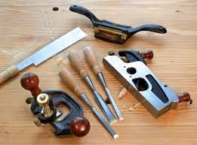](https://www.google.com/imgres?imgurl=https://22293-presscdn-pagely.netdna-ssl.com/wp-content/uploads/2011/02/Oct08_Page_61_Image_0001.jpg&imgrefurl=https://www.popularwoodworking.com/articleindex/the-wood-whisperer-my-favorite-power-tool-accessories&docid=8AfR-pFtQL_xLM&tbnid=NeKfZrrQ7Tb8YM:&vet=10ahUKEwiYmLWgyunZAhWqIMAKHZSrARYQMwhaKBUwFQ..i&w=704&h=521&bih=789&biw=1440&q=woodworking%20hand%20tools(cutting)&ved=0ahUKEwiYmLWgyunZAhWqIMAKHZSrARYQMwhaKBUwFQ&iact=mrc&uact=8)

[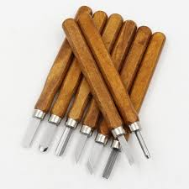](https://www.google.com/imgres?imgurl=https://ae01.alicdn.com/kf/HTB1miQIRXXXXXcuXVXXq6xXFXXXf/12pcs-lot-Professional-Woodworking-Cutting-Parts-Wood-Carving-Hand-Chisel-Tool-Set-Woodworking-Hand-Tools.jpg_640x640.jpg&imgrefurl=https://www.aliexpress.com/item/12pcs-lot-Professional-Woodworking-Cutting-Parts-Wood-Carving-Hand-Chisel-Tool-Set-Woodworking-Hand-Tools/32812149175.html&docid=syGVNYBqXR_6YM&tbnid=0kaF376iXFO0aM:&vet=10ahUKEwiYmLWgyunZAhWqIMAKHZSrARYQMwhbKBYwFg..i&w=640&h=640&itg=1&bih=789&biw=1440&q=woodworking%20hand%20tools(cutting)&ved=0ahUKEwiYmLWgyunZAhWqIMAKHZSrARYQMwhbKBYwFg&iact=mrc&uact=8)

[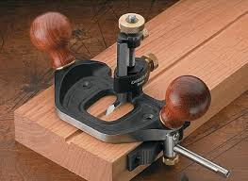](https://www.google.com/imgres?imgurl=https://i.stack.imgur.com/6LEWb.png&imgrefurl=https://woodworking.stackexchange.com/questions/425/making-biscuits-cuts-by-hand&docid=8HNrjRqgk0kTFM&tbnid=Spvr2q1gJAQpJM:&vet=10ahUKEwiYmLWgyunZAhWqIMAKHZSrARYQMwhcKBcwFw..i&w=350&h=255&bih=789&biw=1440&q=woodworking%20hand%20tools(cutting)&ved=0ahUKEwiYmLWgyunZAhWqIMAKHZSrARYQMwhcKBcwFw&iact=mrc&uact=8)

[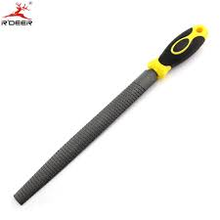](https://www.google.com/imgres?imgurl=https://ae01.alicdn.com/kf/HTB12eZ2LVXXXXczXVXXq6xXFXXX0/Semi-Round-Wood-Files-8-200mm-Pointed-Head-Coarse-Tooth-Double-Lines-For-Woodworking-Hand-Tools.jpg_640x640.jpg&imgrefurl=https://www.aliexpress.com/item/Semi-Round-Wood-Files-8-200mm-Pointed-Head-Coarse-Tooth-Double-Lines-For-Woodworking-Hand-Tools/32633290416.html&docid=T5vaTLMetQ-SxM&tbnid=wEADOFS3PxOp3M:&vet=10ahUKEwiYmLWgyunZAhWqIMAKHZSrARYQMwhdKBgwGA..i&w=640&h=640&bih=789&biw=1440&q=woodworking%20hand%20tools(cutting)&ved=0ahUKEwiYmLWgyunZAhWqIMAKHZSrARYQMwhdKBgwGA&iact=mrc&uact=8)

[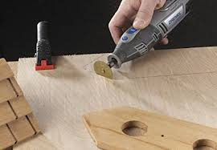](https://www.google.com/imgres?imgurl=https://images-na.ssl-images-amazon.com/images/I/41sD4+mccxL.jpg&imgrefurl=https://www.amazon.com/Dremel-EZ544-Lock-Cutting-Wheel/dp/B000WMK8FI&docid=j4L4KZ2D7_sE0M&tbnid=OVjdOZ8tr8XViM:&vet=10ahUKEwiYmLWgyunZAhWqIMAKHZSrARYQMwheKBkwGQ..i&w=500&h=346&bih=789&biw=1440&q=woodworking%20hand%20tools(cutting)&ved=0ahUKEwiYmLWgyunZAhWqIMAKHZSrARYQMwheKBkwGQ&iact=mrc&uact=8)

[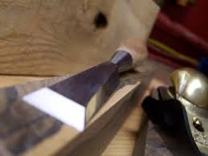](https://www.google.com/imgres?imgurl=http://www.renaissancewoodworker.com/wp-content/uploads/2010/08/macrochisel.jpg&imgrefurl=http://www.renaissancewoodworker.com/getting-started-hand-tool-list/&docid=0ox5EyCUMU27RM&tbnid=Qx7pi312vQtr6M:&vet=10ahUKEwiYmLWgyunZAhWqIMAKHZSrARYQMwhfKBowGg..i&w=2576&h=1932&bih=789&biw=1440&q=woodworking%20hand%20tools(cutting)&ved=0ahUKEwiYmLWgyunZAhWqIMAKHZSrARYQMwhfKBowGg&iact=mrc&uact=8)

[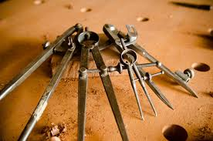](https://www.google.com/imgres?imgurl=https://woodandshop.com/wp-content/uploads/2017/04/wood-and-shop_DSC5347.jpg&imgrefurl=https://woodandshop.com/which-hand-tools-do-you-need-for-traditional-woodworking/&docid=_yMPIPs96PXiyM&tbnid=rquW6-JcpIB_nM:&vet=10ahUKEwiYmLWgyunZAhWqIMAKHZSrARYQMwhgKBswGw..i&w=640&h=424&bih=789&biw=1440&q=woodworking%20hand%20tools(cutting)&ved=0ahUKEwiYmLWgyunZAhWqIMAKHZSrARYQMwhgKBswGw&iact=mrc&uact=8)

[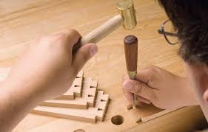](https://www.google.com/imgres?imgurl=https://www.canadianwoodworking.com/sites/default/files/images/articles/handcutdovetails_lead.jpg&imgrefurl=https://www.canadianwoodworking.com/tipstechniques/hand-cut-dovetails&docid=H5o5-CtmLl0iWM&tbnid=BlW8pyAcxQRe6M:&vet=10ahUKEwiYmLWgyunZAhWqIMAKHZSrARYQMwhhKBwwHA..i&w=800&h=510&bih=789&biw=1440&q=woodworking%20hand%20tools(cutting)&ved=0ahUKEwiYmLWgyunZAhWqIMAKHZSrARYQMwhhKBwwHA&iact=mrc&uact=8)

[[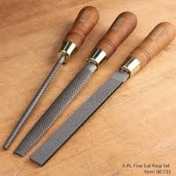](https://www.google.com/imgres?imgurl=https://smhttp-ssl-55170.nexcesscdn.net/media/catalog/product/cache/1/image/9df78eab33525d08d6e5fb8d27136e95/0/0/00-723_base_1_1.jpg&imgrefurl=https://www.infinitytools.com/3-pc-narex-premium-fine-cut-rasp-set&docid=z-GRdD6lnwf-NM&tbnid=Qwc9Jn0nTu5M6M:&vet=10ahUKEwiYmLWgyunZAhWqIMAKHZSrARYQMwhiKB0wHQ..i&w=750&h=750&bih=789&biw=1440&q=woodworking%20hand%20tools(cutting)&ved=0ahUKEwiYmLWgyunZAhWqIMAKHZSrARYQMwhiKB0wHQ&iact=mrc&uact=8)](https://www.google.com/imgres?imgurl=https%3A%2F%2Fsmhttp-ssl-55170.nexcesscdn.net%2Fmedia%2Fcatalog%2Fproduct%2Fcache%2F1%2Fimage%2F9df78eab33525d08d6e5fb8d27136e95%2F0%2F0%2F00-723_base_1_1.jpg&imgrefurl=https%3A%2F%2Fwww.infinitytools.com%2F3-pc-narex-premium-fine-cut-rasp-set&docid=z-GRdD6lnwf-NM&tbnid=Qwc9Jn0nTu5M6M%3A&vet=10ahUKEwiYmLWgyunZAhWqIMAKHZSrARYQMwhiKB0wHQ..i&w=750&h=750&bih=789&biw=1440&q=woodworking%20hand%20tools%28cutting%29&ved=0ahUKEwiYmLWgyunZAhWqIMAKHZSrARYQMwhiKB0wHQ&iact=mrc&uact=8)

[2 days ago](https://www.google.com/imgres?imgurl=https%3A%2F%2Fsmhttp-ssl-55170.nexcesscdn.net%2Fmedia%2Fcatalog%2Fproduct%2Fcache%2F1%2Fimage%2F9df78eab33525d08d6e5fb8d27136e95%2F0%2F0%2F00-723_base_1_1.jpg&imgrefurl=https%3A%2F%2Fwww.infinitytools.com%2F3-pc-narex-premium-fine-cut-rasp-set&docid=z-GRdD6lnwf-NM&tbnid=Qwc9Jn0nTu5M6M%3A&vet=10ahUKEwiYmLWgyunZAhWqIMAKHZSrARYQMwhiKB0wHQ..i&w=750&h=750&bih=789&biw=1440&q=woodworking%20hand%20tools%28cutting%29&ved=0ahUKEwiYmLWgyunZAhWqIMAKHZSrARYQMwhiKB0wHQ&iact=mrc&uact=8)

[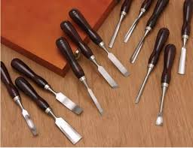](https://www.google.com/imgres?imgurl=http://www.handymantips.org/wp-content/uploads/2015/07/Grizzly-wood-chisels.jpg&imgrefurl=http://www.handymantips.org/types-of-chisels/&docid=7hBWNN5ISA4vYM&tbnid=KdWbZHOSZgumKM:&vet=10ahUKEwiYmLWgyunZAhWqIMAKHZSrARYQMwhkKB4wHg..i&w=600&h=462&bih=789&biw=1440&q=woodworking%20hand%20tools(cutting)&ved=0ahUKEwiYmLWgyunZAhWqIMAKHZSrARYQMwhkKB4wHg&iact=mrc&uact=8)

[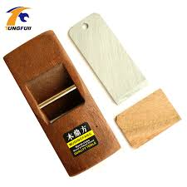](https://www.google.com/imgres?imgurl=https://ae01.alicdn.com/kf/HTB1rXtHSVXXXXbfXFXXq6xXFXXXS/Tungfull-4-107mm-Hand-Planer-Cutting-Edge-Carpenter-Hard-Woodworking-Planer-Wood-Hand-Tools.jpg_640x640.jpg&imgrefurl=https://www.aliexpress.com/item/Tungfull-4-107mm-Hand-Planer-Cutting-Edge-Carpenter-Hard-Woodworking-Planer-Wood-Hand-Tools/32828799688.html&docid=YdwD11AxOw0INM&tbnid=_y_PxmEQNP5kBM:&vet=10ahUKEwiYmLWgyunZAhWqIMAKHZSrARYQMwhlKB8wHw..i&w=640&h=640&itg=1&bih=789&biw=1440&q=woodworking%20hand%20tools(cutting)&ved=0ahUKEwiYmLWgyunZAhWqIMAKHZSrARYQMwhlKB8wHw&iact=mrc&uact=8)

[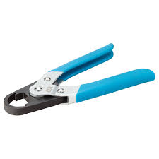](https://www.google.com/imgres?imgurl=http://isabela.iweb.co.uk/image/aHR0cDovL3d3dy5veHRvb2xzLmNvLnVrL21lZGlhL2NhdGFsb2cvcHJvZHVjdC9PL2wvT2xpdmVfQ3V0dGVyXzMuanBn?q=75&h=1500&w=1500&e=1209600&t=outbound&imgrefurl=http://www.oxtools.co.uk/hand-tools.html&docid=jOKNBsJSdIK2NM&tbnid=YB---2sIRQ3x4M:&vet=10ahUKEwiYmLWgyunZAhWqIMAKHZSrARYQMwhmKCAwIA..i&w=1201&h=1201&bih=789&biw=1440&q=woodworking%20hand%20tools(cutting)&ved=0ahUKEwiYmLWgyunZAhWqIMAKHZSrARYQMwhmKCAwIA&iact=mrc&uact=8)

[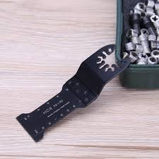](https://www.google.com/imgres?imgurl=https://ae01.alicdn.com/kf/HTB1J6lDq3MPMeJjy1Xcq6xpppXa1/4pcs-set-HCS-Oscillating-MultiTool-Saw-Blade-for-Renovator-Power-Tools-Cutting-Woodworking-Hand-Tools.jpg&imgrefurl=https://www.aliexpress.com/item/4pcs-set-HCS-Oscillating-MultiTool-Saw-Blade-for-Renovator-Power-Tools-Cutting-Woodworking-Hand-Tools/32836609515.html&docid=ZWtzSjC2iCqvvM&tbnid=PqJJ3njdtES65M:&vet=10ahUKEwiYmLWgyunZAhWqIMAKHZSrARYQMwhnKCEwIQ..i&w=800&h=800&itg=1&bih=789&biw=1440&q=woodworking%20hand%20tools(cutting)&ved=0ahUKEwiYmLWgyunZAhWqIMAKHZSrARYQMwhnKCEwIQ&iact=mrc&uact=8)

[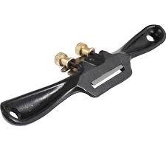](https://www.google.com/imgres?imgurl=https://ae01.alicdn.com/kf/HTB1nIHrcgkLL1JjSZFpq6y7nFXax/9-215mm-Hand-Planer-Cutting-Edge-Woodworking-Planer-Adjustment-Screw-Spoke-Shave-Manual-Woodworking-Hand-Tools.jpg_640x640q90.jpg&imgrefurl=https://m.aliexpress.com/item/32829714276.html&docid=-ioccyxYz2UEZM&tbnid=z_eEo7HVA2347M:&vet=10ahUKEwiYmLWgyunZAhWqIMAKHZSrARYQMwhoKCIwIg..i&w=640&h=640&itg=1&bih=789&biw=1440&q=woodworking%20hand%20tools(cutting)&ved=0ahUKEwiYmLWgyunZAhWqIMAKHZSrARYQMwhoKCIwIg&iact=mrc&uact=8)

[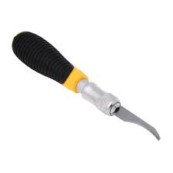](https://www.google.com/imgres?imgurl=https://ae01.alicdn.com/kf/HTB1yYirQFXXXXX0XVXXq6xXFXXXm/DIY-Hobby-Engraving-Knife-Set-Precision-Knife-Cutter-Tools-Wood-Paper-cut-Sculptural-Woodworking-Hand-Tools.jpg&imgrefurl=https://www.aliexpress.com/store/product/DIY-Hobby-Engraving-Knife-Set-Precision-Knife-Cutter-Tools-Wood-Paper-cut-Sculptural-Woodworking-Hand-Tools/2503010_32782175796.html&docid=nNcjYQ4sIn-S5M&tbnid=8CicWgxAVG81XM:&vet=10ahUKEwiYmLWgyunZAhWqIMAKHZSrARYQMwhpKCMwIw..i&w=1000&h=1000&bih=789&biw=1440&q=woodworking%20hand%20tools(cutting)&ved=0ahUKEwiYmLWgyunZAhWqIMAKHZSrARYQMwhpKCMwIw&iact=mrc&uact=8)

[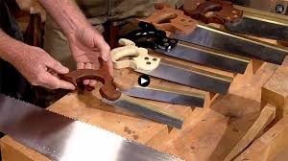](https://www.google.com/imgres?imgurl=https://woodandshop.com/wp-content/uploads/2013/12/tom-calisto-hand-saw-back-saw-maker-woodwrights-shop-video.jpg&imgrefurl=https://woodandshop.com/woodworking-hand-tool-buying-guide-handsaws/&docid=QAg17sQ5wypz9M&tbnid=P6pM_MwdCIu2wM:&vet=10ahUKEwiYmLWgyunZAhWqIMAKHZSrARYQMwhqKCQwJA..i&w=640&h=359&bih=789&biw=1440&q=woodworking%20hand%20tools(cutting)&ved=0ahUKEwiYmLWgyunZAhWqIMAKHZSrARYQMwhqKCQwJA&iact=mrc&uact=8)

[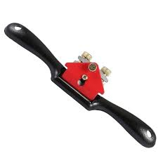](https://www.google.com/imgres?imgurl=https://ae01.alicdn.com/kf/HTB10i2ncm3PL1JjSZFxq6ABBVXaM/9-215mm-Hand-Planer-Cutting-Edge-Woodworking-Planer-Adjustment-Screw-Spoke-Shave-Manual-Woodworking-Hand-Tools.jpg_640x640q90.jpg&imgrefurl=https://m.aliexpress.com/item/32829714276.html&docid=-ioccyxYz2UEZM&tbnid=SKd2Hel4a8i9CM:&vet=10ahUKEwiYmLWgyunZAhWqIMAKHZSrARYQMwhrKCUwJQ..i&w=640&h=640&itg=1&bih=789&biw=1440&q=woodworking%20hand%20tools(cutting)&ved=0ahUKEwiYmLWgyunZAhWqIMAKHZSrARYQMwhrKCUwJQ&iact=mrc&uact=8)

[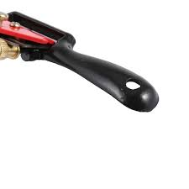](https://www.google.com/imgres?imgurl=https://ae01.alicdn.com/kf/HTB1PI_Ja5IRMeJjy0Fbq6znqXXaj/9-215mm-Hand-Planer-Cutting-Edge-Woodworking-Planer-Adjustment-Screw-Spoke-Shave-Manual-Woodworking-Hand-Tools.jpg_640x640q90.jpg&imgrefurl=https://m.aliexpress.com/item/32829714276.html&docid=-ioccyxYz2UEZM&tbnid=VpvgeS6AS-nSiM:&vet=10ahUKEwiYmLWgyunZAhWqIMAKHZSrARYQMwhsKCYwJg..i&w=640&h=640&itg=1&bih=789&biw=1440&q=woodworking%20hand%20tools(cutting)&ved=0ahUKEwiYmLWgyunZAhWqIMAKHZSrARYQMwhsKCYwJg&iact=mrc&uact=8)

[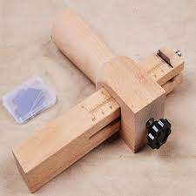](https://www.google.com/imgres?imgurl=https://ae01.alicdn.com/kf/HTB1oo5gRXXXXXXRaFXXq6xXFXXXx/Adjustable-Wooden-StripDIY-Leather-Craft-Tools-Strap-Belt-Cutter-Hand-Cutting-Tools-Belt-Cutter-Pimp-Line.jpg_640x640.jpg&imgrefurl=https://www.aliexpress.com/item/Adjustable-Wooden-StripDIY-Leather-Craft-Tools-Strap-Belt-Cutter-Hand-Cutting-Tools-Belt-Cutter-Pimp-Line/32813303580.html&docid=ofTaQ8YAOsSGcM&tbnid=rTE1OWlQiZt5wM:&vet=10ahUKEwiYmLWgyunZAhWqIMAKHZSrARYQMwhtKCcwJw..i&w=640&h=640&bih=789&biw=1440&q=woodworking%20hand%20tools(cutting)&ved=0ahUKEwiYmLWgyunZAhWqIMAKHZSrARYQMwhtKCcwJw&iact=mrc&uact=8)

[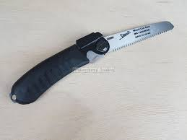](https://www.google.com/imgres?imgurl=https://cdn.shopify.com/s/files/1/2098/3449/products/Japanese_Woodworking_Tools_Australia_ProTooling__Pocket_Folding_Pullsaw_3_1024x1024.jpg?v=1519785269&imgrefurl=https://protooling.com.au/products/shogun-folding-2-in-1-pocket-pull-saw-wood-key-hole-saws&docid=FsO9TjrpCFmYPM&tbnid=rVDJh8GinT85SM:&vet=10ahUKEwiYmLWgyunZAhWqIMAKHZSrARYQMwhuKCgwKA..i&w=1024&h=768&bih=789&biw=1440&q=woodworking%20hand%20tools(cutting)&ved=0ahUKEwiYmLWgyunZAhWqIMAKHZSrARYQMwhuKCgwKA&iact=mrc&uact=8)

[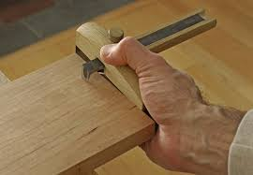](https://www.google.com/imgres?imgurl=http://cdn3.craftsy.com/blog/wp-content/uploads/2015/02/IMG_3517_edited-2.jpg&imgrefurl=https://www.craftsy.com/woodworking/article/marking-gauges/&docid=Pbw4M7PG8UVGDM&tbnid=5TkPscQ69NrbaM:&vet=10ahUKEwiYmLWgyunZAhWqIMAKHZSrARYQMwhvKCkwKQ..i&w=600&h=415&bih=789&biw=1440&q=woodworking%20hand%20tools(cutting)&ved=0ahUKEwiYmLWgyunZAhWqIMAKHZSrARYQMwhvKCkwKQ&iact=mrc&uact=8)

[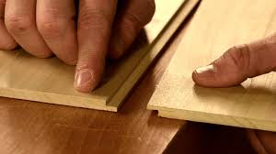](https://www.google.com/imgres?imgurl=https://i.ytimg.com/vi/gG9_vxOS99Y/maxresdefault.jpg&imgrefurl=https://www.youtube.com/watch?v=gG9_vxOS99Y&docid=2h7UCGodD-lq4M&tbnid=ehV8skCamFXfaM:&vet=10ahUKEwiYmLWgyunZAhWqIMAKHZSrARYQMwhwKCowKg..i&w=1419&h=798&bih=789&biw=1440&q=woodworking%20hand%20tools(cutting)&ved=0ahUKEwiYmLWgyunZAhWqIMAKHZSrARYQMwhwKCowKg&iact=mrc&uact=8)

[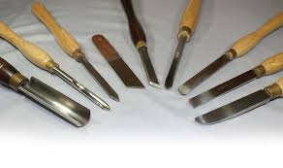](https://www.google.com/imgres?imgurl=https://www.canadianwoodworking.com/sites/default/files/images/articles/woodturningtools_lead.jpg&imgrefurl=https://www.canadianwoodworking.com/tools/woodturning-tools-new-turner&docid=AnBDxYm1HDjVOM&tbnid=RxhXvH1l_RCR0M:&vet=10ahUKEwiYmLWgyunZAhWqIMAKHZSrARYQMwhxKCswKw..i&w=800&h=474&bih=789&biw=1440&q=woodworking%20hand%20tools(cutting)&ved=0ahUKEwiYmLWgyunZAhWqIMAKHZSrARYQMwhxKCswKw&iact=mrc&uact=8)

[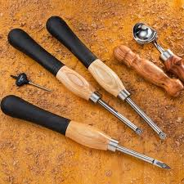](https://www.google.com/imgres?imgurl=http://assets.rockler.com/media/catalog/product/cache/1/image/720x720/9df78eab33525d08d6e5fb8d27136e95/4/5/45142-12-1000.jpg&imgrefurl=http://www.rockler.com/carbide-mini-turning-tool-3-piece-set&docid=XEFIC9tZ2DMWIM&tbnid=ASPQjbNahUvmvM:&vet=10ahUKEwiYmLWgyunZAhWqIMAKHZSrARYQMwh4KDIwMg..i&w=720&h=720&bih=789&biw=1440&q=woodworking%20hand%20tools(cutting)&ved=0ahUKEwiYmLWgyunZAhWqIMAKHZSrARYQMwh4KDIwMg&iact=mrc&uact=8)

[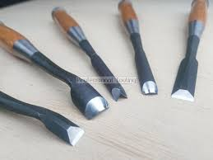](https://www.google.com/imgres?imgurl=https://cdn.shopify.com/s/files/1/2098/3449/products/Japanese_Woodworking_Tools_Australia_ProTooling__Premium_Wood_Carving_Chisel_Set__4_1024x1024.jpg?v=1519785713&imgrefurl=https://protooling.com.au/products/shogun-makoto-5-premium-wood-carving-set-5-x-chisels-in-timber-box&docid=WUwPBWpi8J3NtM&tbnid=5FcEgaBagy3CoM:&vet=10ahUKEwiYmLWgyunZAhWqIMAKHZSrARYQMwh5KDMwMw..i&w=1024&h=768&bih=789&biw=1440&q=woodworking%20hand%20tools(cutting)&ved=0ahUKEwiYmLWgyunZAhWqIMAKHZSrARYQMwh5KDMwMw&iact=mrc&uact=8)

[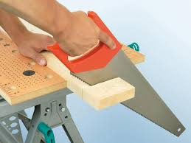](https://www.google.com/imgres?imgurl=https://diy.sndimg.com/content/dam/images/diy/fullset/2011/2/23/7/RX-DK-DIY034010_saw-thru-wood_s4x3.jpg.rend.hgtvcom.616.462.suffix/1420781392354.jpeg&imgrefurl=https://www.diynetwork.com/how-to/skills-and-know-how/tools/how-to-cut-wood-with-a-hand-saw&docid=s7_kXixYRlI86M&tbnid=zXLXyPC8li19KM:&vet=10ahUKEwiYmLWgyunZAhWqIMAKHZSrARYQMwh6KDQwNA..i&w=616&h=462&bih=789&biw=1440&q=woodworking%20hand%20tools(cutting)&ved=0ahUKEwiYmLWgyunZAhWqIMAKHZSrARYQMwh6KDQwNA&iact=mrc&uact=8)

[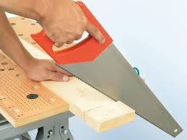](https://www.google.com/imgres?imgurl=https://diy.sndimg.com/content/dam/images/diy/fullset/2011/2/23/5/RX-DK-DIY034008_hold-the-saw_s4x3.jpg.rend.hgtvcom.1280.960.suffix/1420764999572.jpeg&imgrefurl=https://www.diynetwork.com/how-to/skills-and-know-how/tools/how-to-cut-wood-with-a-hand-saw&docid=s7_kXixYRlI86M&tbnid=bU5vkSTq7GXLUM:&vet=10ahUKEwiYmLWgyunZAhWqIMAKHZSrARYQMwh7KDUwNQ..i&w=1280&h=961&bih=789&biw=1440&q=woodworking%20hand%20tools(cutting)&ved=0ahUKEwiYmLWgyunZAhWqIMAKHZSrARYQMwh7KDUwNQ&iact=mrc&uact=8)

|  |  |
| --- | --- |
|  |  |
|  |  |

|  |
| --- |
|  |

[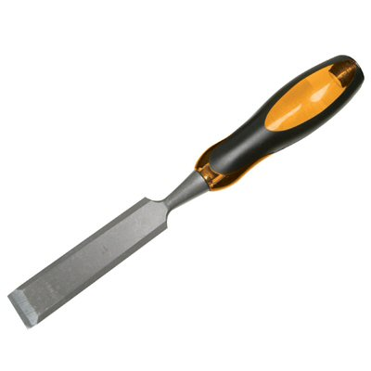](http://tooltime.txdi.org/handtoolscutting)

1.define boring tool

2.list 5 wood work cutting tools

Week 3; wood work hand tools [cont]



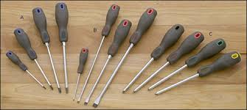

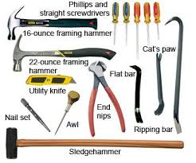

Holding devices;

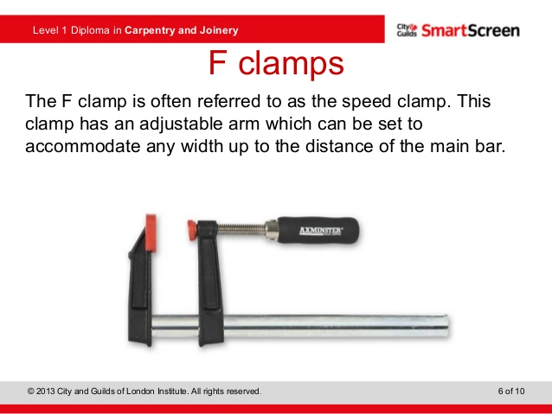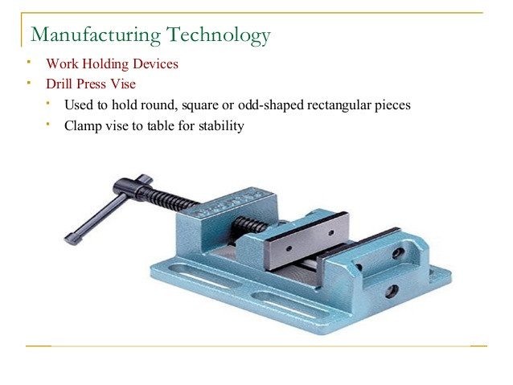

Care and maintanance of wood work tools;

The Basics:  
• Begin with a tune-up: New handplanes, chisels, and other hand tools rarely come fully sharpened and tuned. This part is up to you.  
• Keep it sharp: One good sharpening and constant upkeep are essential.  
• Prevent rust and damage: Proper tool storage is essential to prolong the life of your tools.

**Begin with a tune-up**  
[Most new planes don’t come ready to use](http://www.finewoodworking.com/ToolGuide/ToolGuidePDF.aspx?id=2933). More times than not, the sole will have a hollow in its length or width that must be corrected before the tool will work properly, or the plane iron will need sharpening. Chisels, scrapers, and other hand tools usually need a similar tune-up to remove burrs and other metal irregularities that might interfere with performance.

**Keep it sharp**  
Woodworkers who have mastered the ins and outs of [sharpening](http://www.finewoodworking.com/SkillsAndTechniques/SkillsAndTechniquesPDF.aspx?id=2060) are justly proud of the sharpness of their hand tools. There are a number of sharpening techniques that woodworkers swear by; choose one and use it regularly.

**Prevent rust and damage**  
Once a hand tool is well tuned, it takes effort to keep it that way. Unlike most modern power tools, hand tools will last for generations if they are well cared for. A [toolbox](http://www.finewoodworking.com/ProjectsAndDesign/ProjectsAndDesignPDF.aspx?id=2306) or other storage device that is sealed from moisture and the elements is the first line of defense against rust. You might also consider storing hand tools in a product called Ferro-Pak, a brand of paper that is treated with a rust inhibitor. Many hand-tool manufacturers ship products wrapped in this. Aside from rust, great care should be taken to protect hand tools from dents and scratches to keep them

working with precision.

1.define driving tool

2, explain 2 methods of maintenainning wood work hand tools

Week 4; metal work hand tools

**A**

* [Angle plate](https://en.wikipedia.org/wiki/Angle_plate)

**B**

* [Bore gauge](https://en.wikipedia.org/wiki/Bore_gauge)

**C**

* [Calipers](https://en.wikipedia.org/wiki/Calipers)
* [Center gauge](https://en.wikipedia.org/wiki/Center_gauge)
* [Combination square](https://en.wikipedia.org/wiki/Combination_square)
* [Coordinate-measuring machine](https://en.wikipedia.org/wiki/Coordinate-measuring_machine)

**D**

* [Drawbar force gauge](https://en.wikipedia.org/wiki/Drawbar_force_gauge)

**E**

* [Engineer's blue](https://en.wikipedia.org/wiki/Engineer%27s_blue)
* [Engineer's spirit level](https://en.wikipedia.org/wiki/Engineer%27s_spirit_level)

**F**

* [Feeler gauge](https://en.wikipedia.org/wiki/Feeler_gauge)

**G**

* [Gauge block](https://en.wikipedia.org/wiki/Gauge_block)
* [Go/no go gauge](https://en.wikipedia.org/wiki/Go/no_go_gauge)

**H**

* [Height gauge](https://en.wikipedia.org/wiki/Height_gauge)

**I**

* [Indicator (distance amplifying instrument)](https://en.wikipedia.org/wiki/Indicator_%28distance_amplifying_instrument%29)

**M**

* [Machinist square](https://en.wikipedia.org/wiki/Machinist_square)
* [Marking blue](https://en.wikipedia.org/wiki/Marking_blue)
* [Marking gauge](https://en.wikipedia.org/wiki/Marking_gauge)
* [Marking out](https://en.wikipedia.org/wiki/Marking_out)
* [Micrometer](https://en.wikipedia.org/wiki/Micrometer)

**O**

* [Optical comparator](https://en.wikipedia.org/wiki/Optical_comparator)

**P**

* [Parallels (engineering)](https://en.wikipedia.org/wiki/Parallels_%28engineering%29)
* [Profilometer](https://en.wikipedia.org/wiki/Profilometer)

**R**

* [Radius gauge](https://en.wikipedia.org/wiki/Radius_gauge)
* [Ring gauge](https://en.wikipedia.org/wiki/Ring_gauge)
* [Ruler](https://en.wikipedia.org/wiki/Ruler)

**S**

* [Scale ruler](https://en.wikipedia.org/wiki/Scale_ruler)
* [Sine bar](https://en.wikipedia.org/wiki/Sine_bar)
* [Snap gage](https://en.wikipedia.org/wiki/Snap_gage)
* [Straightedge](https://en.wikipedia.org/wiki/Straightedge)
* [Surface plate](https://en.wikipedia.org/wiki/Surface_plate)

**T**

* [Tape measure](https://en.wikipedia.org/wiki/Tape_measure)
* [Thread pitch gauge](https://en.wikipedia.org/wiki/Thread_pitch_gauge)

**U**

* [Universal measuring machine](https://en.wikipedia.org/wiki/Universal_measuring_machine)

**W**

* [Wiggler (tool)](https://en.wikipedia.org/wiki/Wiggler_%28tool%29)

Marking out tools;

**Marking-Out Tools Used on Metal**

**What allows tools to cut, shape and mark-out pieces of metal?**  
So that all of these tools can scratch and punch into a piece of mild steel, they have  
to be HARDER than it. Special Tool-steel Is used to make these tools. They also  
receive special treatment, to make and keep them hard.  
  
ENGINEERS SQUARE  
This ‘all-metal” square is similar to the Try Square used on wood. However, the Engineers Square is smaller and more accurate. It’s purpose is the same, to draw lines at 90 to an edge and to check if  
work is a perfect right-angle; as below.

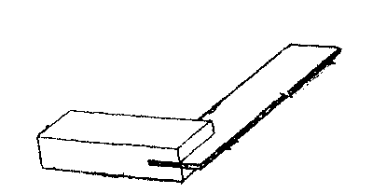

SCRIBER  
These are used to draw/scratch lines onto the surface of a piece of metal. They must  
not be used for anything else, as the thin, sharp point us easily mined If misused. Correct use is shown below.

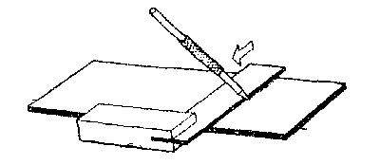

ODD LEG CALiPERS  
Once “odd-legs” have been set to a required measurement, they are used to draw a line along a piece of metal. This line will be parallel to the edge it is drawn along: as below. Odd—legs are the ‘metal equivalent” to a marking gauge, used when marking out wood.

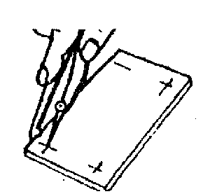

MARKING-OUT BLUE  
Special sharp and hard tools are needed to mark-out lines on metal. As these lines become very difficult to see, scratched on a thin layer of “marking-out blue" is brushed on first. A pemanent marker-pen can be used in place of the “blue ink-like” liquid  
  
DOT PUNCH  
Sharp lines tend to disappear while filing metal, as Burrs are constantly produced On the edge of a piece of metal. In order that lines can be seen more clearly feint dots, called WITNESS MARKS. can be lightly punched around the entire shape (that will be cut-out). A dot punch is used, along with a hammer: to create witness marks. Rest the work on a block of metal to do this, not in a vice. (The point is ground or sharpened to make an angle of 60 degrees)

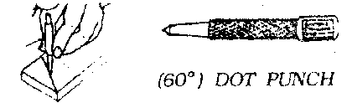  
  
CENTRE PUNCH  
A centre punch is a larger version of a dot punch but it is not as sharp at the point. It is very difficult to start drilling a hole In a piece of metal, at an exact position. The point of the drill needs a large dot, to ‘lead  
It in”. A centre punch needs to be hit with greater force, to create a deeper dot. (Point ground to 90 degrees)



DIVIDERS

The sharp points on both ends are used to mark out circles and curves onto a piece of metal.

Also once the dividers have been set at a measurement they can be used to mark off lots of equal distances along a line.

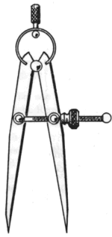

Holding devices; Metal work-holding devices are used for holding objects in position during cutting operations. They include vices and clamps.

**1.Vices:** Vices are used for holding heavy jobs. The different types of vices are as follows:

(i). **Bench vice:** This is a device fastened to the workbench near its edge, used for all types of heavy work, like filing, chipping, sawing, etc. eg

[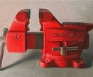](http://4.bp.blogspot.com/-fkahiFZGWhY/UlUWUZXpNqI/AAAAAAAAAq4/W2Muaj1x-cY/s1600/is%5b2%5d.jpg)

(ii).**Hand vice:** The hand vice is used where the work piece to be held by the bench vice seems to be too small to be held conveniently .eg.

[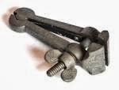](http://2.bp.blogspot.com/-vySQi97fta0/UlUXvUNEZlI/AAAAAAAAArM/SpmY-B2PSPs/s1600/images%5b1%5d.jpg)

(iii). **Machine vice:** The machine vice is used for holding work down on the table for the purpose of milling, shaping, drilling, etc. eg.

[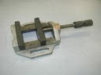](http://4.bp.blogspot.com/-skHUp-ivtTQ/UlUWe1pt7eI/AAAAAAAAArA/lXl2W8COmdA/s1600/is%5b1%5d.jpg)

**2. Clamps:** Clamps are handy tools of various used for smaller articles. They include the following:  
(i). **Pliers:** These are very handy tools of various sizes and shapes used for the general purposes of holding small articles and for cutting small wires. They can also be used for pulling, pushing, turning and twisting.eg.

[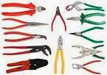](http://2.bp.blogspot.com/-SGm9KZOnnEE/UlUYEijMFHI/AAAAAAAAArU/EsWnR3yV6VQ/s1600/images%5b3%5d.jpg)

(ii). **Toolmaker’s clamp:** This is a clamp used for holding parts together during assembling (coupling parts together), riveting, clamping work piece during drilling. Eg.

[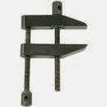](http://1.bp.blogspot.com/-Ly3c9XCLGDA/UlUYl3xP--I/AAAAAAAAArg/Mf8495JGpUs/s1600/images%5b5%5d.jpg)

## REVIEW QUESTIONS

(i). name two types of vices used in a metal workshop.  
(ii). explain the uses of the vices listed above.

Week 5; metal work hand tools [cont]

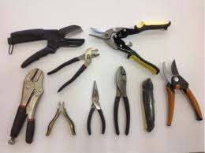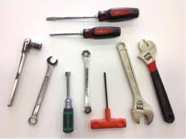

Cutting tools;

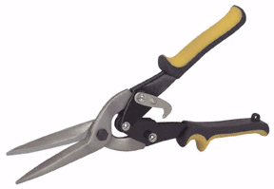

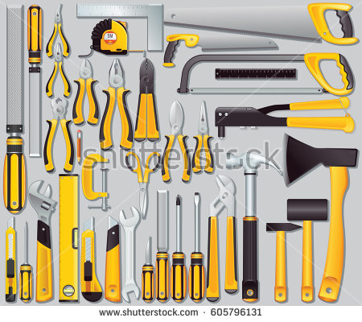

Boring tools

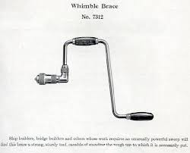

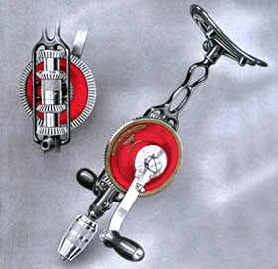

When it comes to machine tools, it's extremely important to perform the proper maintenance on them in order to ensure their longevity. Whether it's the maintenance on a machine's motor, operational components, or specific attachments, the importance of routine check-ups cannot be stressed enough.

The last thing that you want to have happen is a machine breakdown because of improper maintenance. In order to properly conduct a maintenance check-up, here are some steps that should be followed:

**Check the lubrication:**

For machine tools that are frequently used, it's extremely important to inspect the machine's lubrication levels on a weekly basis. By ensuring that the moving parts are properly lubricated, you will be able to protect the motor over an extended period of time.

This includes greasing of moving parts, oiling or internal moving components and visual inspection of all part movement in action. Without the right amount of oil, grease or other lubricant, any machine tool could face unnecessary wear and tear. This could lead to breaking downs or extreme damage.

**Sharpen important components:**

If you are using machinery that has components designed for sharpening, cutting, slicing or chopping, you need to ensure that these components maintain their sharpness. If you don't perform routine maintenance on specific parts that need to sustain a particular sharpness, you could be putting production quality at a very high risk.

The sharpness of a machine part is important because you need to make sure that cut materials are shaped correctly and accurately. This could include checking the sharpness of tools like end bills, drill bits, lathe tools and precision cutters.

**Check alignment specifications:**

The last thing that you want when it comes to your machine tool is to have a particular component or attachment out of alignment. This could greatly affect your work quality in a very negative way. To determine if your machine tool is properly aligned, simply perform a few test jobs and measure the resulting parts to inspect how the equipment is currently working. If the alignment is off, you will need to realign the machine in order to maintain accurate specifications.

**Inspect the cleanliness:**

Although this is somewhat obvious, you need to make sure that your machine is cleaned on a regular basis. By cleaning various pieces of equipment either daily or weekly, you will ensure that a machine is running at maximum capacity. The cleanliness of a machine can often be taken for granted and overlooked when it comes to specific parts breaking down. For example, when a machine collects a lot of grime or begins to rust, long-term problems can start to appear.

**Take good care of accessories and parts:**

In order to properly maintain your machine tool, it's very important to perform routine maintenance checks on all of your components and accessories. An important part of this preventative care is to make sure that all of you machine parts and accessories are handled and stored responsibly. You definitely don't want to be careless with any part of your machine tool.

Common sense plays a major role here. Use all of you senses to detect potential problems. An odd sound, a strange smell or unordinary vibration can mean trouble. All things that can be more easily taken care of when detected early on. Keeping a checklist and carefully logging all maintenance performed will optimize this process.

1.list 5 metal work cutting tool

2.explain 2 methods of boring holes in metals

Week 6 .importance of maintenance

Tool Maintenance Made Easy

posted on August 15, 2017 by Matt Becker



If you're like most woodworkers, you've invested a lot in your tool collection, both financially and in the time you've spent choosing, acquiring and setting up the tools that make up your shop. But how much time have you devoted to taking good care of them?

Taking care of your tools is important, and if you've been neglecting your tool maintenance program because you think it involves lots of specialized equipment and complicated, time-consuming machinery tear-downs, we've got good news. With just a few facts, a modest investment in [tool maintenance equipment and supplies](http://www.rockler.com/c/tool-tune-up-maintenance.cfm), and a little time, you can keep all of the tools in your shop running at peak performance year-round.

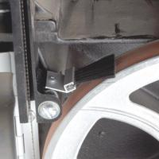

**What Tool Maintenance can do for Your Shop**

At the most fundamental level, woodshop tool maintenance simply means keeping your tools operating as well as they did when you took them out of the box. That's a minimum requirement for running a safe, successful shop. But a good tool maintenance regimen can take you even further. Taking a few extra steps in caring for work surfaces, cutting edges, alignment mechanisms and moving parts can work wonders for the performance of your tools. Add in a few affordable power tool upgrades and you can improve the performance of your woodworking machinery beyond like-new condition. Below, we'll show you how easy it can be to go beyond the basics in keeping the tools in your shop *sharp, true, clean*, and *running smooth*.

**Part I - Keeping Them Sharp**

Most of the tools in a woodshop are designed to do one thing - cut wood. Naturally, one of the most important aspects of tool maintenance is keeping cutting edges as sharp as possible. In fact, your safety and the quality of your woodworking depends on doing a good job here. From sharpening systems for hand tools to simply outfitting your tools with the best bits and blades, there's a lot that you can do to give yourself the "edge" when it comes to cutting and machining parts.

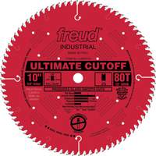

**Circular saw blades**

Most woodworkers who've been at it for a while shop for bits and blades from manufacturers they trust. [Circular saw blades](http://www.rockler.com/c/table-saw-chop-saw-radial-arm-saw-blades.cfm) from Freud and Forrest are manufactured from the highest quality carbide and tool steel, and designed to keep an edge through continued use. These manufacturers also produce blades designed to stand up to applications that can be very rough on cutting edges, like cutting man-made substrates and laminates. There's really no alternative to paying a professional sharpening service to put a new edge on a circular saw blade - it's actually cheaper in the long run to spend a little extra on blades that can go a long time between sharpenings.

**Router bits**

Router bits usually need to be replaced when they become very dull or damaged. That's a good reason to stay away from discount bits and bit sets. Rockler's own line of [router bits](http://www.rockler.com/c/router-bits.cfm), and those from reputable manufacturers like Amana and Freud, are manufactured using the highest quality carbide and tool steel, meaning that they can be kept in service for years without needing to be replaced.

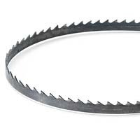

**Band saw blades**

[Band saw blades](http://www.rockler.com/c/band-saw-blades.cfm) are another cutting tool that are almost always replaced rather than sharpened. Make replacing your band saw blade with a premium blade a standard part of your maintenance schedule. You'll be money and time ahead in the long run.

**Drill bits**

What about [drill bits](http://www.rockler.com/c/drill-bits.cfm)? Once again, buying the best set of bits you can afford to begin with is the best solution for a dull drill bit problem. A good set of [forstner bits](http://www.rockler.com/product.cfm?page=10615), if used correctly, will stand up to a lot of use before they lose their edge. But even the best drill bits get dull after a certain amount of sustained use, and a dull drill bit can cause ragged hole-edges and burning. If you're the type who likes to speed through drilling operations, leaving nothing but crisp, clean-edged holes in your wake, a sharpening system that works for most popular drill bit types, like the [Drill Doctor](http://www.rockler.com/product.cfm?page=16779), would be a sound tool maintenance investment.

**Hand tools**

Hand tools - planes, chisels, gouges and the like - absolutely require an adequate sharpening system. A good sharpening system for the delicate cutting edges of fine hand tools will allow you to do two things: grind the tool to the correct shape, and hone it to a near-perfect edge. Here you have a few options. Perfectly acceptable results can be achieved using a grinder outfitted with a cool-running [white aluminum oxide grinding wheel](http://www.rockler.com/product.cfm?page=10088) and a fairly simple honing system, like Rockler's [Plate Glass Sharpening System](https://www.rockler.com/product.cfm?page=5983).

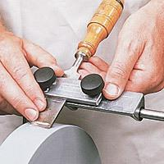

If hand tools figure prominently in your woodworking, consider investing in a more advanced sharpening system. The [Delta Sharpening Station](https://www.rockler.com/delta-tools) is an excellent all-in-one sharpening system at an affordable price. And if you want the top of the line, it doesn't get any better than the [Tormek Sharpening System](https://www.rockler.com/tormek-t-7-sharpening-system).

Sharpening hand tools is really an art form in itself, and it would be impossible to do it justice here. That's why we'd like to recommend another precision sharpening tool: a sharpening book. Both Leonard Lee's [Complete Guide to Sharpening](http://www.rockler.com/product.cfm?page=1920) and [Taunton's Complete Illustrated Guide to Sharpening](http://www.rockler.com/product.cfm?page=11097) offer in-depth information that can bump your sharpening techniques up to the expert level.

**Part II - Keeping Them True**

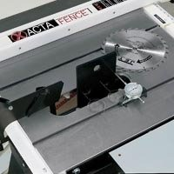

Keeping tools in proper alignment is of paramount importance to the performance and accuracy of woodworking tools and equipment. Once set up and adjusted, quality woodworking machinery generally stays in alignment for a long period. But vibration and continued use will eventually cause even the best machinery to go out of adjustment. This is an area where a [book or DVD](http://www.rockler.com/c/tool-books-videos.cfm) dedicated to a specific power tool can really help out. Many contain detailed information both on how to use the tool and on how to keep in top form. While we can't cover the subject of adjustment and alignment in detail for every woodworking machine, we can offer a few suggestions for two of the most used tools in your shop.

**Table saw alignment**

For the centerpiece of your shop - your **table saw** - it also helps to have a tool to help keep things lined up. For a table saw to produce smooth cuts, and to avoid safety risks, the blade must be aligned to run parallel with the miter slot and fence. The [Master Plate With Super Bar](http://www.rockler.com/product.cfm?page=6039) table saw calibration system will help you diagnose alignment problems and keep your table saw blade running perfectly true.

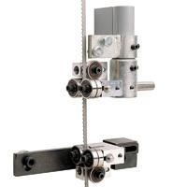

Upgrading your table saw's fence and miter gauge is one of the easiest ways to improve its performance. Many contractor grade saws are outfitted with excellent basic components - the bed and the motor are fine - but sometimes an exceptional quality fence and miter gauge aren't part of the bargain. Adding an accurate [fence system](http://www.rockler.com/product.cfm?page=5933) and a precision [miter gauge](http://woodworking.rockler.com/c/table-saw-miter-gauges-tenoning-jigs-fences) will greatly increase the accuracy and reliability of many table saws.

**Band saw tracking and alignment**

Your band saw's ability to make a true cut without wander can be improved by an upgrade to it's blade guiding system. Simply adding a set of [ceramic guide blocks](http://www.rockler.com/product.cfm?page=6542) will significantly improve the tracking performance of most band saws. And adding [Carter Band Saw Guides](https://www.rockler.com/product.cfm?page=5008) can transform an ordinary band saw into a professional class machine.

**Part III - Keeping Them Clean and Smooth**

In woodworking, friction is the enemy, and that makes keeping your tools clean and free of pitch and resin buildup extremely important. While your first line of defense against woodworking debris will always be an adequate [dust collection system](http://www.rockler.com/c/dust-collection.cfm), you'll still need to keep power tool surfaces that come in contact with the wood clean and properly lubricated.



**Keeping saw blades clean**

Especially when you are sawing pitchy softwoods, it doesn't take long for your table saw blade to get loaded up with a coat of pitch and resin. The sticky residue causes drag, vibration, and a buildup of extra heat, all of which affect not only your woodworking experience, but also the quality of the cut. A few squirts of [Rockler Pitch and Resin Remover](https://www.rockler.com/product.cfm?page=11122) and a quick polish at blade-change time will keep your circular saw blades clean and smooth.

**Cleaning and conditioning router bits**

Your router bits are another likely candidate for periodic cleaning. There is often only a small amount of clearance between a router bit's cutting edge and its body, where resin buildup can significantly add to the friction created during the cut. You can use the same cleaner that you use for your saw blades to keep your router bits bright and shiny. And for lasting protection, pick up the [Blade and Bit Maintenance Kit](https://www.rockler.com/product.cfm?page=18197). The kit includes both a generous supply of pitch and resin remover and a lubricant specially designed to condition and protect router bit pilot bearings.

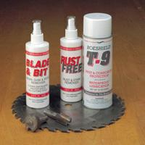

**Stationary tool surfaces**

The surfaces of your table saw, jointer, band saw and planer are designed to support the workpiece and allow it to pass smoothly through the cut. To keep them performing up to par, these surfaces need to be kept clean and free of corrosion. And to enhance their performance, most woodworking experts advocate a light lubrication. The [Boesheild 3-Part Tool Care Kit](https://www.rockler.com/product.cfm?page=2380) include everything you need to restore the work surfaces of your tools to their original stain and corrosion-free condition, remove pitch and resin, and lubricate them with a lubricant designed especially for power tool care.

**Part IV - Keeping Them Running Smooth**

Here you have a great opportunity to improve your woodworking and help your tools age gracefully at the same time. Power tools - at least good ones - are designed to stand up to heavy use, but if you want them to stay that way for a lifetime, you have to take care of their mechanical parts. To protect your investment, make sure that all of your tools and machinery are kept in good working order and properly lubricated. Along with the basic considerations, there are a few mechanical upgrades that, in many cases, will improve a power tool's performance beyond like-new condition.



**Lubricating bearings and moving parts**

The lubricant you use to keep your tools' moving part and bearings in top condition should be designed for the job. [Bearing lubricant](https://www.rockler.com/product.cfm?page=5706) penetrates bearings to protect and seal internal parts, reduce heat buildup and extend the life of the tool. For long, trouble-free service from all of your stationary and handheld power tools, lubricate all bearings and moving parts on a regular basis. You can also improve the performance of your band saw, scroll saw and coping saw blades with a Blade Lubricant Stick. Made with a special blend of wax and oils, the lubricant stick extends blade life and helps prevent clogging.

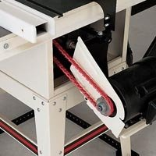

**Mechanical Upgrades for Power Tools**

Worn out drive belts cause increased vibration and slippage - not to mention the tendency they have to break at the most inopportune times. When it's time to change belts, you have an opportunity to increase the performance of most tools by upgrading to a [Power Twist Link Belt](https://www.rockler.com/product.cfm?page=6040). The Power Twist belt is made up of interlocking segments of tough polyurethane elastomer and multiple plies of polyester fabric. The unique feature of the belt is its removable link design, which allows the belt's length to be adjusted to provide optimal tension for a variety of tools. The Power Twist also hold its shape far better than standard drive belts The result is greatly increased belt life and reduced tool vibration of up to35%.

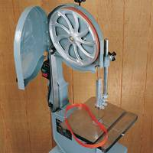

Band saw tires are one of the most neglected mechanical components in woodworking. The usual rubber band saw tires are often left on long after they've lost flexibility and begun to crack. The cost in tool performance is increased vibration, reduced blade life and poor tracking. Unlike rubber tires, [Urethane Band Saw Tires](https://www.rockler.com/urethane-band-saw-tires-fits-12-bandsaw) never dry out, meaning that you'll retain the exceptional, vibration-free blade tracking of a new tire for a long time. The tires retain their shape and fit tight to the wheel. You don't need to glue them down, so if they ever do wear out, changing them is quick and easy.

While you're servicing your band saw, check to see if it is equipped with an integral wheel brush. If it isn't, do yourself a favor and get an add-on [Wheel Brush](https://www.rockler.com/product.cfm?page=11331) to keep your new band saw tires free of the dust and debris that can have a serious effect on blade performance. For the money, a wheel brush is one of the most cost effective tool improvements you can make.

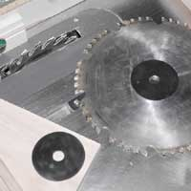

Anything you can do to limit vibration is worth the effort. Vibration shows up in poor tool performance and less than desirable cut surfaces - and it takes its toll on moving parts and bearings. Adding a [blade stabilizer](https://www.rockler.com/product.cfm?page=10507) to tools that use circular saw blades is one more step in the right direction. Blade stabilizers, which can be used on most stationary tools that use 7' and larger circular blades, reduce blade rim vibration and increase blade life while limiting the level of vibration that would otherwise be transmitted to your saw's arbor bearings.

**Staying on top of it**

In the long run, it's a lot easier to develop a tool maintenance program and stick with it than it is to rescue and replace tools that have been neglected. Establish a maintenance schedule and stick with it. Above, we've tried to cover the most important tool maintenance considerations, but you'll find even more useful [tool maintenance supplies and equipment](http://www.rockler.com/c/saw-blade-accessories.cfm) at Rockler.

* 1. Define maintenance
  2. Mention 3 types of maintenance

Week 7. Basic electricity

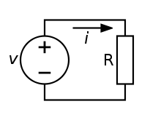

An **electric circuit** is a path in which [electrons](https://simple.wikipedia.org/wiki/Electrons) from a [voltage](https://simple.wikipedia.org/wiki/Voltage) or [current](https://simple.wikipedia.org/wiki/Electric_current) source flow.

Components of electric circuit

The three basic principles for this lesson can be explained using electrons, or more specifically, the charge they create:

***Voltage*** is the difference in charge between two points.

***Current*** is the rate at which charge is flowing.

***Resistance*** is a material's tendency to resist the flow of charge (*current*).

An **electronic** **circuit** is composed of individual **electronic** **components**, such as resistors, transistors, capacitors, inductors and diodes, connected by conductive wires or traces through which **electric** current can flow.

An electric current is a flow of electric charge. In electric circuits this charge is often carried by moving electrons in a wire.

Definition

# Ohm's Law

Ohm's Law is the mathematical relationship among electric [current](http://searchcio-midmarket.techtarget.com/definition/current), [resistance](http://searchcio-midmarket.techtarget.com/definition/resistance), and [voltage](http://searchcio-midmarket.techtarget.com/definition/voltage). The principle is named after the German scientist Georg Simon Ohm.

In directyt-current (DC) circuits, Ohm's Law is simple and linear. Suppose a resistance having a value of R [ohm](http://whatis.techtarget.com/definition/ohm)s carries a current of I [ampere](http://searchcio-midmarket.techtarget.com/definition/ampere)s. Then the voltage across the resistor is equal to the product IR. There are two corollaries. If a DC power source providing E [volt](http://searchcio-midmarket.techtarget.com/definition/volt)s is placed across a resistance of R ohms, then the current through the resistance is equal to E/R amperes. Also, in a DC circuit, if E volts appear across a component that carries I amperes, then the resistance of that component is equal to E/I ohms.

Mathematically, Ohm's Law for DC circuits can be stated as three equations:

E = IR

I = E/R

R = E/I

## Type of current Electric current has two types: alternating current, or AC, and direct current, or DC. Both types have their own specific uses in terms of power generation and use, although AC is the more common type in home use. The difference is that direct current only flows in one direction, while alternating current switches directions rapidly. Electricity

Electricity is a result of the movement of electrons. In all substances, the negatively charged electrons in atoms move around randomly. When the electrons begin to flow in a particular direction within a substance, or from one object to another, the result is electricity. The movement of electrons can be harnessed for energy. Electron movements occur when two objects are rubbed together and electrons are transferred from one to another, which is static electricity. When electrons flow in a current, such as through through a conductor like copper wire, the electricity is called electric current.

## Current

Electric current is the flow of electrons, but electrons do not jump directly from the origin point of the current to the destination. Instead, each electron moves a short distance to the next atom, transferring its energy to an electron in that new atom, which jumps to another atom, and so on.The individual electrons do not move quickly, but the current itself moves at the speed of light. Current flow heats up the conductor. This mechanic produces light in lightbulbs and heat in electric stovetops.

## Direct Current

Direct current is electric current that only flows in one direction. A common place to find direct current is in batteries. A battery is first charged using direct current that is then transformed into chemical energy. When the battery is in use, it turns the chemical energy back into electricity in the form of direct current. Batteries need direct current to charge up, and will only produce direct current.

## Alternating Current

Alternating current, as the name implies, alternates in direction. Alternating current is used for the production and transportation of electricity. This is because when electricity is produced in large scale, such as in a power plant, it has dangerously high voltage. It is easier and cheaper to downgrade this current to lower voltage for home use when the current is AC. However, there Westinghouse successfully lit the 1893 Chicago World's Fair using AC. Since then, alternating current powers homes and anything else that draws on the current in power lines.

1.define transformer

2,what is the function of stablizers

Week 8.

Basic electricity **Electrical measuring instruments**, from the name itself, refer to devices used for measuring various electrical aspects such as the presence and amount of current, voltage, resistance and power through installation. Measuring these aspects is important to determine if the electrical system is installed appropriately. Some electrical measuring instruments that measure one of the electrical aspects mentioned are ammeters, voltmeter and ohmmeters.

Ammeters

Ammeters are electrical instruments utilized to measure current in a circuit. The evaluation it does in the flow of current is read in “amps” as the unit. Ammeters are available in various designs which allow them to test the presence and amount of current in electrical devices of different sizes. They are used in various applications both residential and commercial use. The wiring system of new buildings needs to be checked to make sure they are properly working. This can be done with the use of ammeter. It is also used by electricians to see if there are problems on the wiring system of older buildings. Manufacturing companies involve in the production of electrical equipment also utilize this electrical measuring instrument to test the products before they are supplied to the market for sale. There are ammeters that can measure direct current, alternating current or both. They have to be properly set to avoid short circuit or the device to malfunction as ammeters tend to have low resistance.

Voltmeter

Voltmeters are electrical devices that measure the voltage or potential difference between two points in a circuit. The units of measure of voltmeters are expressed in “volts”. Voltage works by connecting it parallel to the circuit. There are analog and digital voltmeters which difference can be distinctly recognized by how the readings are presented. Analog voltmeters show the voltage through a pointer that moves across the scale while digital voltmeters provide a numerical display of voltage. Voltmeters are also made available in a variety of styles. There are portable voltmeters, also known as multimeter for its ability to measure current and resistance, applied in testing electrical and electronics work. The ability of multimeter to measure voltage, resistance and current is made possible by Ohm’s Law. Fixed apparatus such as generators need instruments that can be mounted in a panel permanently.

Ohmmeter

Ohmmeters, which uses ohm as unit of measurement, are devices that measure the electrical resistance through a circuit. These equipment are important on installations that require correct resistance in order to function properly such as speakers. Ohmmeters also check the flow of current to make sure that it is running continuously. Today, ohmmeters come with digital displays which can provide much more accuracy on the readings. To ensure the precision of the result, an ohmmeter should be used on checking the resistance of a device that generates its own current. For this electrical measuring instrument to work properly, it should measure resistance according to the flow of current coming from its own battery. Interference from an external current source may result to false readings.

Multimeters

Multimeters are a popular type of electrical measuring instrument because of its versatility. It works like an ammeter, ohmmeter and voltmeter for it can measure current, voltage as well as resistance. Similar to other electrical measuring instruments, multimeters are available in analog and digital type

ohmmeters

Ohmmeters, which uses ohm as unit of measurement, are devices that measure the electrical resistance through a circuit. These equipment are important on installations that require correct resistance in order to function properly such as speakers. Ohmmeters also check the flow of current to make sure that it is running continuously. Today, ohmmeters come with digital displays which can provide much more accuracy on the readings. To ensure the precision of the result, an ohmmeter should be used on checking the resistance of a device that generates its own current. For this electrical measuring instrument to work properly, it should measure resistance according to the flow of current coming from its own battery. Interference from an external current source may result to false readings.

Multimeters

Multimeters are a popular type of electrical measuring instrument because of its versatility. It works like an ammeter, ohmmeter and voltmeter for it can measure current, voltage as well as resistance. Similar to other electrical measuring instruments, multimeters are available in analog and digital types

1.define current

2.explain electric circuit and its component

Week 9.basic electricity

**● The** [**Formula Wheel**](http://www.google.com/search?hl=en&q=sengpielaudio.com+formula+wheel&filter=0) **–** [**Formulas of Electrical Engineering**](http://www.google.com/search?hl=en&q=sengpielaudio.com+formulas+of+electrical+engineering) **●**    
**for** [**electric voltage**](http://www.google.com/search?hl=en&q=sengpielaudio.com+electric+voltage&filter=0) ***V*,** [**current**](http://www.google.com/search?hl=en&q=sengpielaudio.com+electrical+current&filter=0) ***I*,** [**resistance**](http://www.google.com/search?hl=en&q=sengpielaudio.com+electrical-resistance&filter=0) ***R*,** [**impedance**](http://www.google.com/search?hl=en&q=sengpielaudio.com+impedance&filter=0) ***Z*,** [**power**](http://www.google.com/search?hl=en&q=sengpielaudio.com+electrical+power&filter=0) ***P***  
**Magic circle − Formulas for calculating any combination of electrical units**

|  |  |  |  |  |  |  |  |  |  |  |  |  |  |  |  |  |  |  |  |  |  |
| --- | --- | --- | --- | --- | --- | --- | --- | --- | --- | --- | --- | --- | --- | --- | --- | --- | --- | --- | --- | --- | --- |
| |  |  |  | | --- | --- | --- | | **Principles of Electrical Engineering** [**Physics**](http://www.google.com/search?hl=en&q=sengpielaudio.com+physics&filter=0) [**Formulary**](http://www.google.com/search?hl=en&q=sengpielaudio.com+formulary&filter=0) **and** [**Electricity**](http://www.google.com/search?hl=en&q=sengpielaudio.com+electricity&filter=0) [**Equations**](http://www.google.com/search?hl=en&q=sengpielaudio.com+equations&filter=0) | | | |  | | | | [***Formula Wheel***](http://www.google.com/search?hl=en&q=sengpielaudio.com+formula+wheel&filter=0) | ▼ | [***Important Formulas***](http://www.google.com/search?hl=en&q=sengpielaudio.com+formulas&filter=0) | | ***Electrical engineering laws*** |  | ***Electronic engineering laws*** | | **Electrical formulas as circle diagram (pie chart)** | | | |  | | | | [Formula wheel electronics](http://www.sengpielaudio.com/calculator-ohm.htm) | | | |

|  |
| --- |
| ***V*** comes from "voltage" and ***E*** from "electromotive force emf". ***E*** means also **energy**, so let's choose ***V***. Energy = voltage × charge. ***E*** = ***V*** × ***Q***. Some like better to stick to ***E*** instead to ***V***, so do it. |

|  |
| --- |
| Voltage ***V*** = *I* × *R* = *P* / *I* = √(*P* × *R*) in volts V          Current ***I*** = *V* / *R* = *P* / *V* = √(*P* / *R*) in amperes A Resistance ***R*** = *V* / *I* = *P* / *I*2 = *V*2/ *P* in ohms Ω      Power ***P*** = *V* × *I* = R × *I*2= *V*2/ *R* in watts W |

[**Electric current, electric power, electricity − Formulas and calculations**](http://www.sengpielaudio.com/calculator-ohm.htm)

**Electric voltage *V* = *I* × *R*      (Ohm's law formula)**  
Electric voltage = amperage × resistance  
   
Please enter **two** values, the third value will be calculated.

Top of Form

|  |  |  |  |  |  |  |  |  |  |  |  |  |
| --- | --- | --- | --- | --- | --- | --- | --- | --- | --- | --- | --- | --- |
| |  |  |  | | --- | --- | --- | |  | | | | Electric voltage *V* | volts | Magic triangle volt | | Amperage *I* | amps | | Resistance *R* | ohms | |  |  | |

Bottom of Form

|  |  |
| --- | --- |
|  |  |

Top of Form

|  |  |  |
| --- | --- | --- |
| |  | | --- | |  | | ***V = I × R***              ***I = V ⁄ R***              ***R = V ⁄ I*** | |

Bottom of Form

**Electric power *P* = *I* × *V*      (Watt's power law formula)**  
Electric power = amperage × voltage  
   
Please enter **two** values, the third value will be calculated.

Top of Form

|  |  |  |  |  |  |  |  |  |  |  |  |  |
| --- | --- | --- | --- | --- | --- | --- | --- | --- | --- | --- | --- | --- |
| |  |  |  | | --- | --- | --- | |  | | | | Electric Power *P* | watts | Magic triangle volt | | Amperage *I* | amps | | Voltage *V* | volts | |  |  | |

Bottom of Form

|  |
| --- |
|  |

|  |  |  |  |  |
| --- | --- | --- | --- | --- |
| Top of Form   |  |  |  | | --- | --- | --- | | |  | | --- | |  | | ***P = I × V***              ***I = P ⁄ V***              ***V = P ⁄ I*** | |   Bottom of Form  **If the unit of power *P = I × V*** **and of voltage *V = I · R* is needed** **look for** Red Power Dot**"The Big Power Formulas":** [**Calculations: Power (watt), voltage, current, and resistance**](http://www.sengpielaudio.com/calculator-ohm.htm)  1.what is the formula for calculating current, voltage and resistance  2.define ohms law   |  | | --- | |  | |

Week 10.

Electrical circuit connection

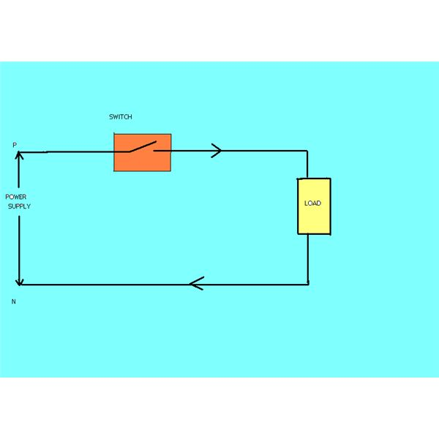

Assignment

* 1. Draw electric circuit 2. Draw a circuit diagram that will indicate current,voltage and resistance 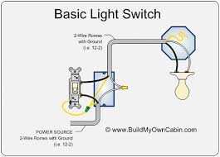s